Experiment No. 3

Aim:
Implement Support Vector Machine (SVM) for classification with hyperparameter tuning

Theory:
Support Vector Machine (SVM) is a supervised machine learning algorithm used mainly for classification tasks. The main goal of SVM is to find an optimal decision boundary, called a hyperplane, that separates different classes in the dataset. In a two-dimensional space, this boundary is a straight line; in higher dimensions, it becomes a plane or hyperplane. Unlike other algorithms that only try to separate classes, SVM focuses on maximizing the margin, which is the distance between the hyperplane and the nearest data points from each class. These nearest data points are called support vectors, and they play a crucial role because the position of the hyperplane depends entirely on them.
The core idea behind SVM is margin maximization. A larger margin generally leads to better generalization and lower risk of overfitting. There are two types of margins in SVM: hard margin and soft margin. Hard margin SVM assumes that the data is perfectly separable and does not allow any misclassification. However, real-world data is usually noisy and overlapping, so soft margin SVM is more commonly used. Soft margin introduces a regularization parameter called C, which controls the trade-off between maximizing the margin and minimizing classification errors. A small value of C allows more misclassification and creates a wider margin (risk of underfitting), while a large value of C tries to classify all points correctly but may lead to overfitting.
SVM can handle both linear and non-linear data. When data is linearly separable, a linear kernel can be used. However, whesn data is not linearly separable, SVM uses a technique called the kernel trick. The kernel trick transforms the original data into a higher-dimensional space where it becomes linearly separable. Common kernel functions include:
- Linear kernel

- Polynomial kernel

- Radial Basis Function (RBF) kernel

- Sigmoid kernel

Among these, the RBF kernel is most commonly used because it can model complex decision boundaries. In non-linear kernels like RBF, another important hyperparameter is gamma (γ). Gamma controls the influence of a single training example. A small gamma value produces a smoother decision boundary (risk of underfitting), while a large gamma creates a complex boundary that may overfit the data.
Hyperparameter tuning is an essential part of implementing SVM because the performance of the model strongly depends on parameters such as C, gamma, kernel type, and degree (for polynomial kernel). Hyperparameter tuning means finding the best combination of these parameters to achieve optimal accuracy and generalization. One common method is Grid Search, where multiple combinations of parameters are tested systematically. Another method is Random Search, where random combinations are tested. These methods are usually combined with Cross-Validation, especially k-fold cross-validation, to ensure that the model performs well on unseen data. In k-fold cross-validation, the dataset is divided into k equal parts; the model is trained on k−1 parts and tested on the remaining part, and this process is repeated k times to compute the average performance.
Before applying SVM, data preprocessing is very important. Since SVM is distance-based, feature scaling (such as Standardization or Normalization) must be performed. Without scaling, features with larger numerical values may dominate the model. After preprocessing, the dataset is split into training and testing sets. The SVM model is trained on the training data, hyperparameters are tuned using GridSearchCV or similar techniques, and the final model is evaluated using metrics such as accuracy, precision, recall, F1-score, and confusion matrix.
SVM has several advantages, such as working well in high-dimensional spaces, being effective when the number of features is greater than the number of samples, and being robust against overfitting when properly tuned. However, it can be computationally expensive for very large datasets, difficult to interpret, and sensitive to the choice of kernel and hyperparameters.
In conclusion, Support Vector Machine is a powerful and mathematically strong classification algorithm that works by finding an optimal hyperplane with maximum margin. By using kernel functions and hyperparameter tuning techniques like Grid Search with cross-validation, SVM can effectively handle both linear and non-linear classification problems and achieve high performance on real-world datasets.

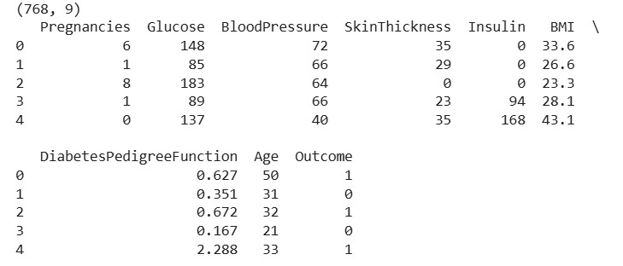
Implementation:

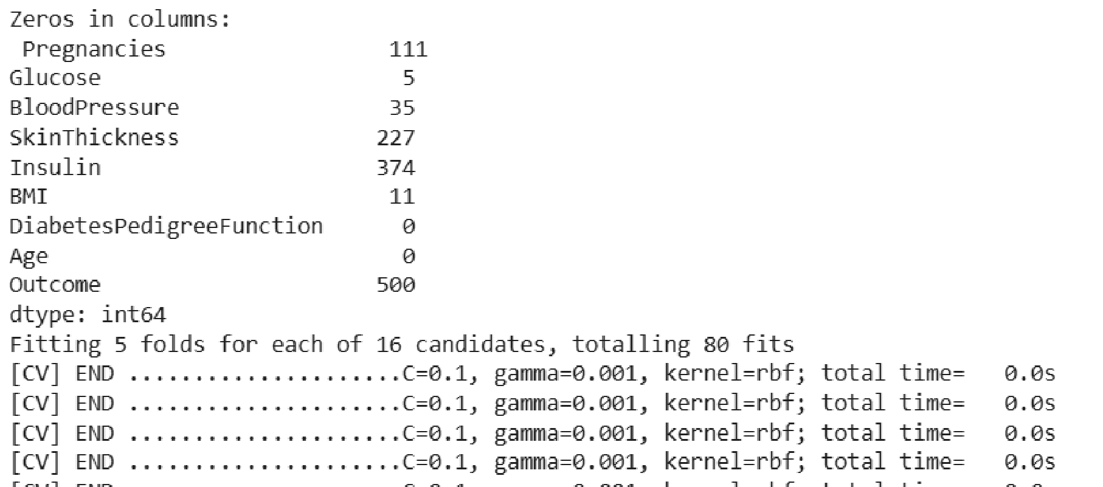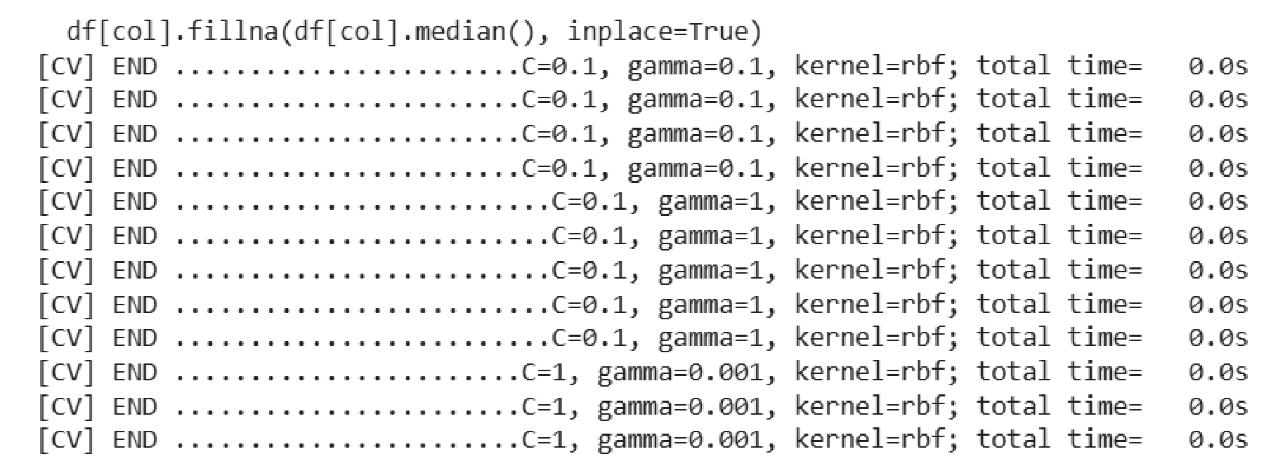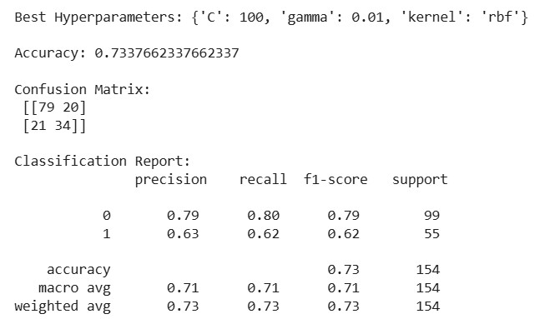

Conclusion: Support Vector Machine (SVM) is a powerful classification algorithm that finds an optimal hyperplane by maximizing the margin between classes. With proper hyperparameter tuning of C, gamma, and kernel using cross-validation, SVM can effectively handle both linear and non-linear data. It provides strong generalization performance when correctly scaled and tuned.

